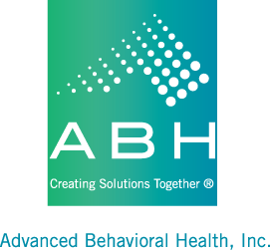

Mental Health Waiver Recovery Assistance Training
Dates for the available RA trainings conducted by ABH from May 2022-July 2022 are as follows:

Training Date Register until (or when class is full)
7/6/22 7/1/22 noon
7/20/22 7/18/22 noon
8/10/22 8/8/22 noon
8/24/22 8/22/22 noon
9/14/22 9/12/22 noon
9/28/22 9/26/22 noon

Please make sure that you have already submitted a criminal background check to ABH before registering someone for a training. Attendees must be able to access training virtually with a device that has a camera and microphone. Sign in is available starting at 8:30am the day of the training and we suggest a trial sign in the day before to test equipment. Training starts promptly at 9am and no late entries are allowed. Attendees must be present during the entire training (until approximately noon) in order to complete the training.

Please email Criminal Background Checks and training registration requests to:
Maria Michaud mmichaud@abhct.com

