Mental Health Waiver Contacts
Toll-Free Number: 1-866-548-0265

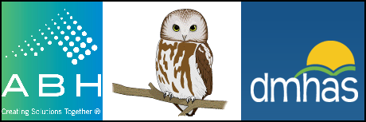

DMHAS Administration:
Erin Leavitt-Smith, LPC, Assistant Director, Statewide Svc (860)-262-6966 erin.leavitt-smith@ct.gov
Cheryl Janes, LCSW, Program Manager (860) 262-6956 cheryl.janes@ct.gov
Mary Ives, Administrative Assistant (860) 262-6957 mary.ives@ct.gov

ABH Staff:
Ann Marie Luongo, LPC, Program Manager (860) 704-6211 aluongo@abhct.com
Lori-Lynn French, Quality Assurance Supervisor (860) 704-6177 lfrench@abhct.com
Maria Michaud, Program Specialist (860) 638-5341 mmichaud@abhct.com
Chasaree Dow, Utilization Review Specialist (860) 704-6186 cdow@abhct.com
Jenny Demars, Claims Coordinator (860) 704-6254 jdemars@abhct.com

