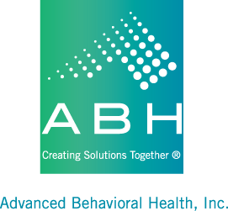
May 1, 2023

Dear Mental Health Waiver Participant,

Two years ago, our Provider Agencies were required to begin using Electronic Visit Verification to record when staff arrive and leave your home. Utilization of this system is mandated by the Centers for Medicare and Medicaid which oversees all Medicaid Waiver Programs. You may have noticed that your staff are using an app on their mobile phone to check in at the beginning and end of their time with you each day. Or they may have asked to use your phone to call into the system. They are required to do this in order to document their time, complete a task list, and allow their agency to bill for their services.

They should also be asking you to verify their time each day. If they are using the app on their mobile phone, then you may have to use your finger to sign your name. Or if they are using your phone to call into the system, they may be passing the phone to you at some point so you can verbally verify their time with you. If this is not happening, you may want to remind them about it or perhaps speak to their supervisor.

We are sending this letter now because with the Public Health Emergency coming to an end, Electronic Visit Verification requirements that were placed on hold will now become effective again. So your staff will become more diligent about using this system. You may need to allow staff to use your phone for these visit verifications. If you have an issue with staff using your phone, please let your Waiver Clinician know so that your team can try and resolve the issue. Again, using this system is a requirement so it is important for your team to resolve this issue so it does not impact services.

If you have any questions or concerns about this system, please reach out to your Waiver Clinician, or you can also contact me at 860-704-6211.

Sincerely,
Ann Marie Luongo

Ann Marie Luongo
ABH, Inc.
MHW Program Manager

